Enterprise Software Platforms

HW #4 - JENKINS

**Team (Technocrats)**

Vijaylaxmi Nagurkar

Monica Dommaraju

Sruthi Chilukuri

Geethu padachery

# 

**EC2 Setup** **3**

**Installing Jenkins** **3**

**Configuring Firewall Settings** **5**

**Setting up EC2 Security Groups** **6**

**Jenkins Setup** **7**

**Git WebHooks** **21**

**GitHub Integration With Jenkins** **22**

# 

# 

# 

# 

# 

# EC2 Setup

Step 1.

Log into your AWS console search for and launch the EC2 instances

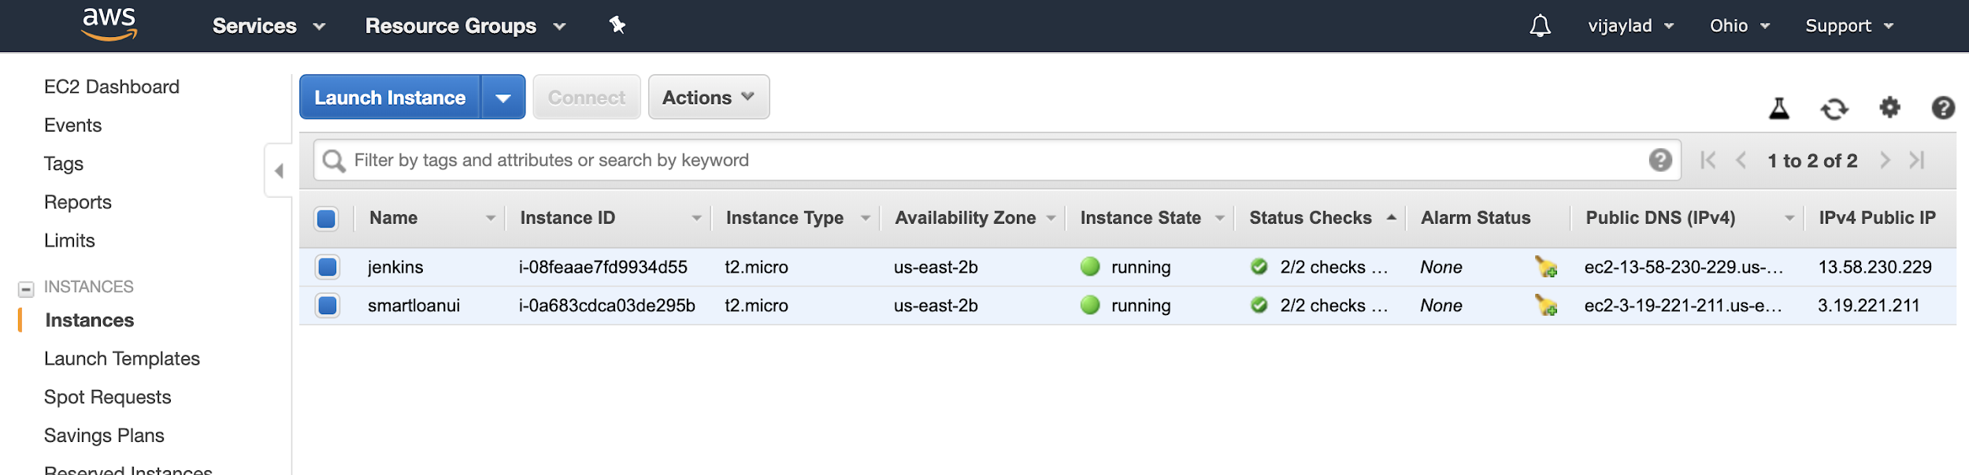

Step 2

Confirm that port 22 is configured to allow access to your VM

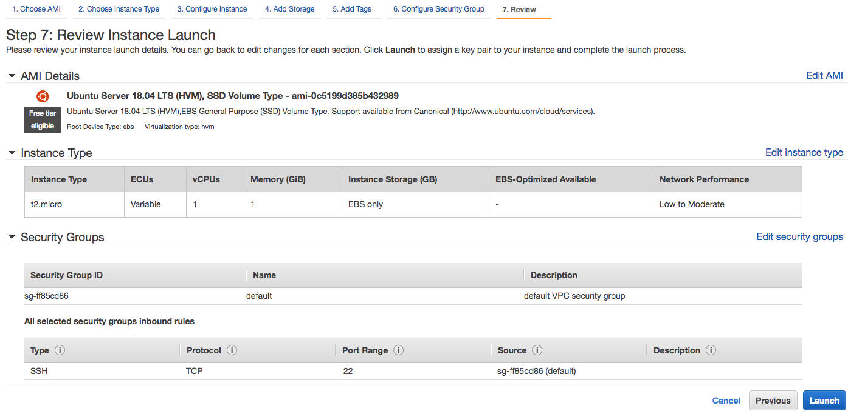

# Installing Jenkins

* Connect to the aws instance
* Install Java
* Configure Oracle JDK8 As Default
* Check the Java version

**javac -version**

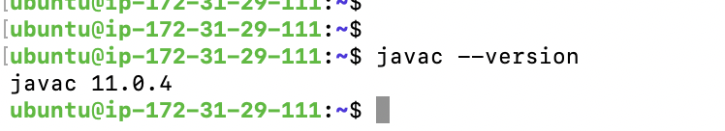

* Install Jenkins

Run the following commands

* cd /tmp && wget -q -O - https://pkg.jenkins.io/debian-stable/jenkins.io.key | sudo apt-key add -
* cd
* sudo apt update
* sudo apt install jenkins

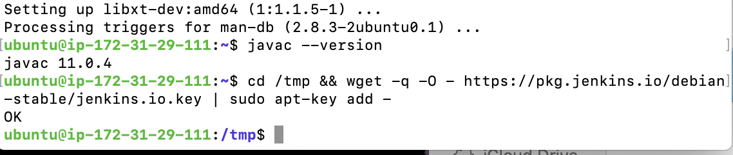

Check status

sudo systemctl status jenkins

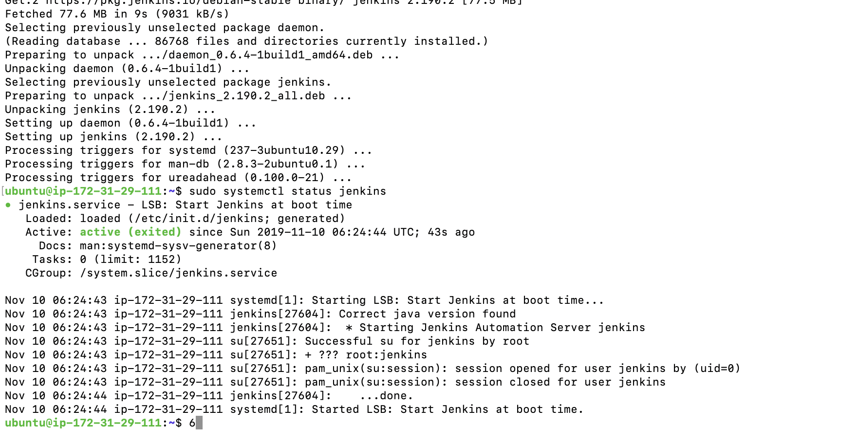

# Configuring Firewall Settings

Give access to ports 8080 and 22

sudo ufw allow 8080

sudo ufw allow 22

Check the status

sudo ufw status

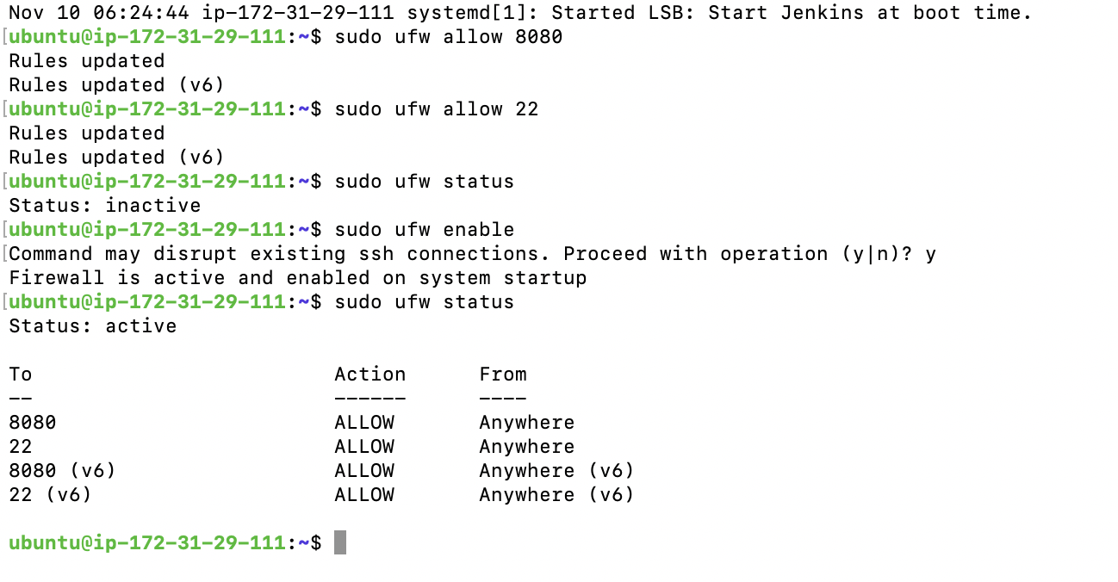

# 

# 

# 

# 

# Setting up EC2 Security Groups

Expose port 8080 in the Security Group

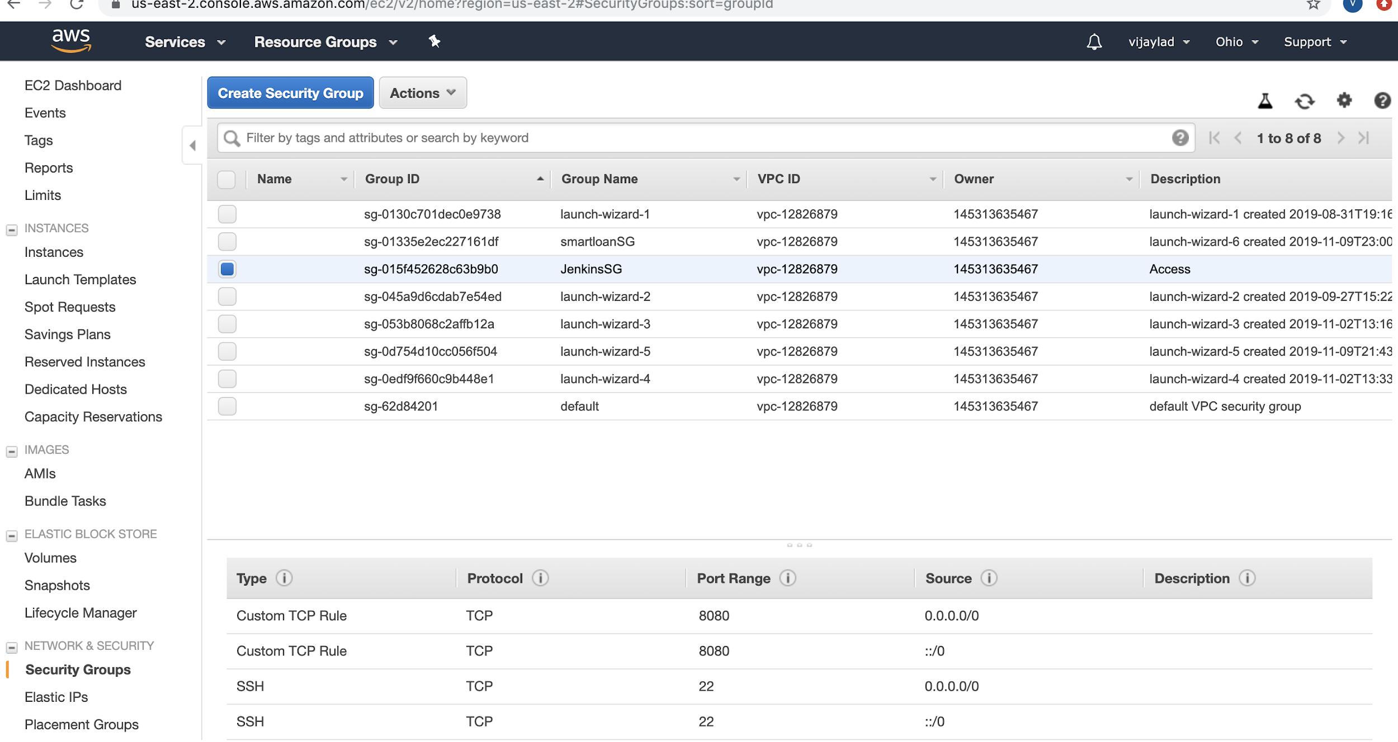

# 

# 

# Jenkins Setup

Visit Jenkins as follows

[http://ec2_instance_ip_address:8080](http://ec2_instance_ip_address:8080/)

sudo cat /var/lib/jenkins/secrets/initialAdminPassword

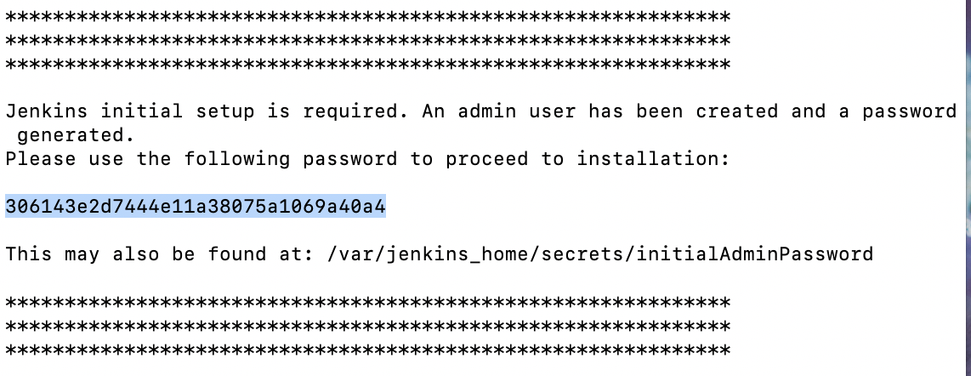

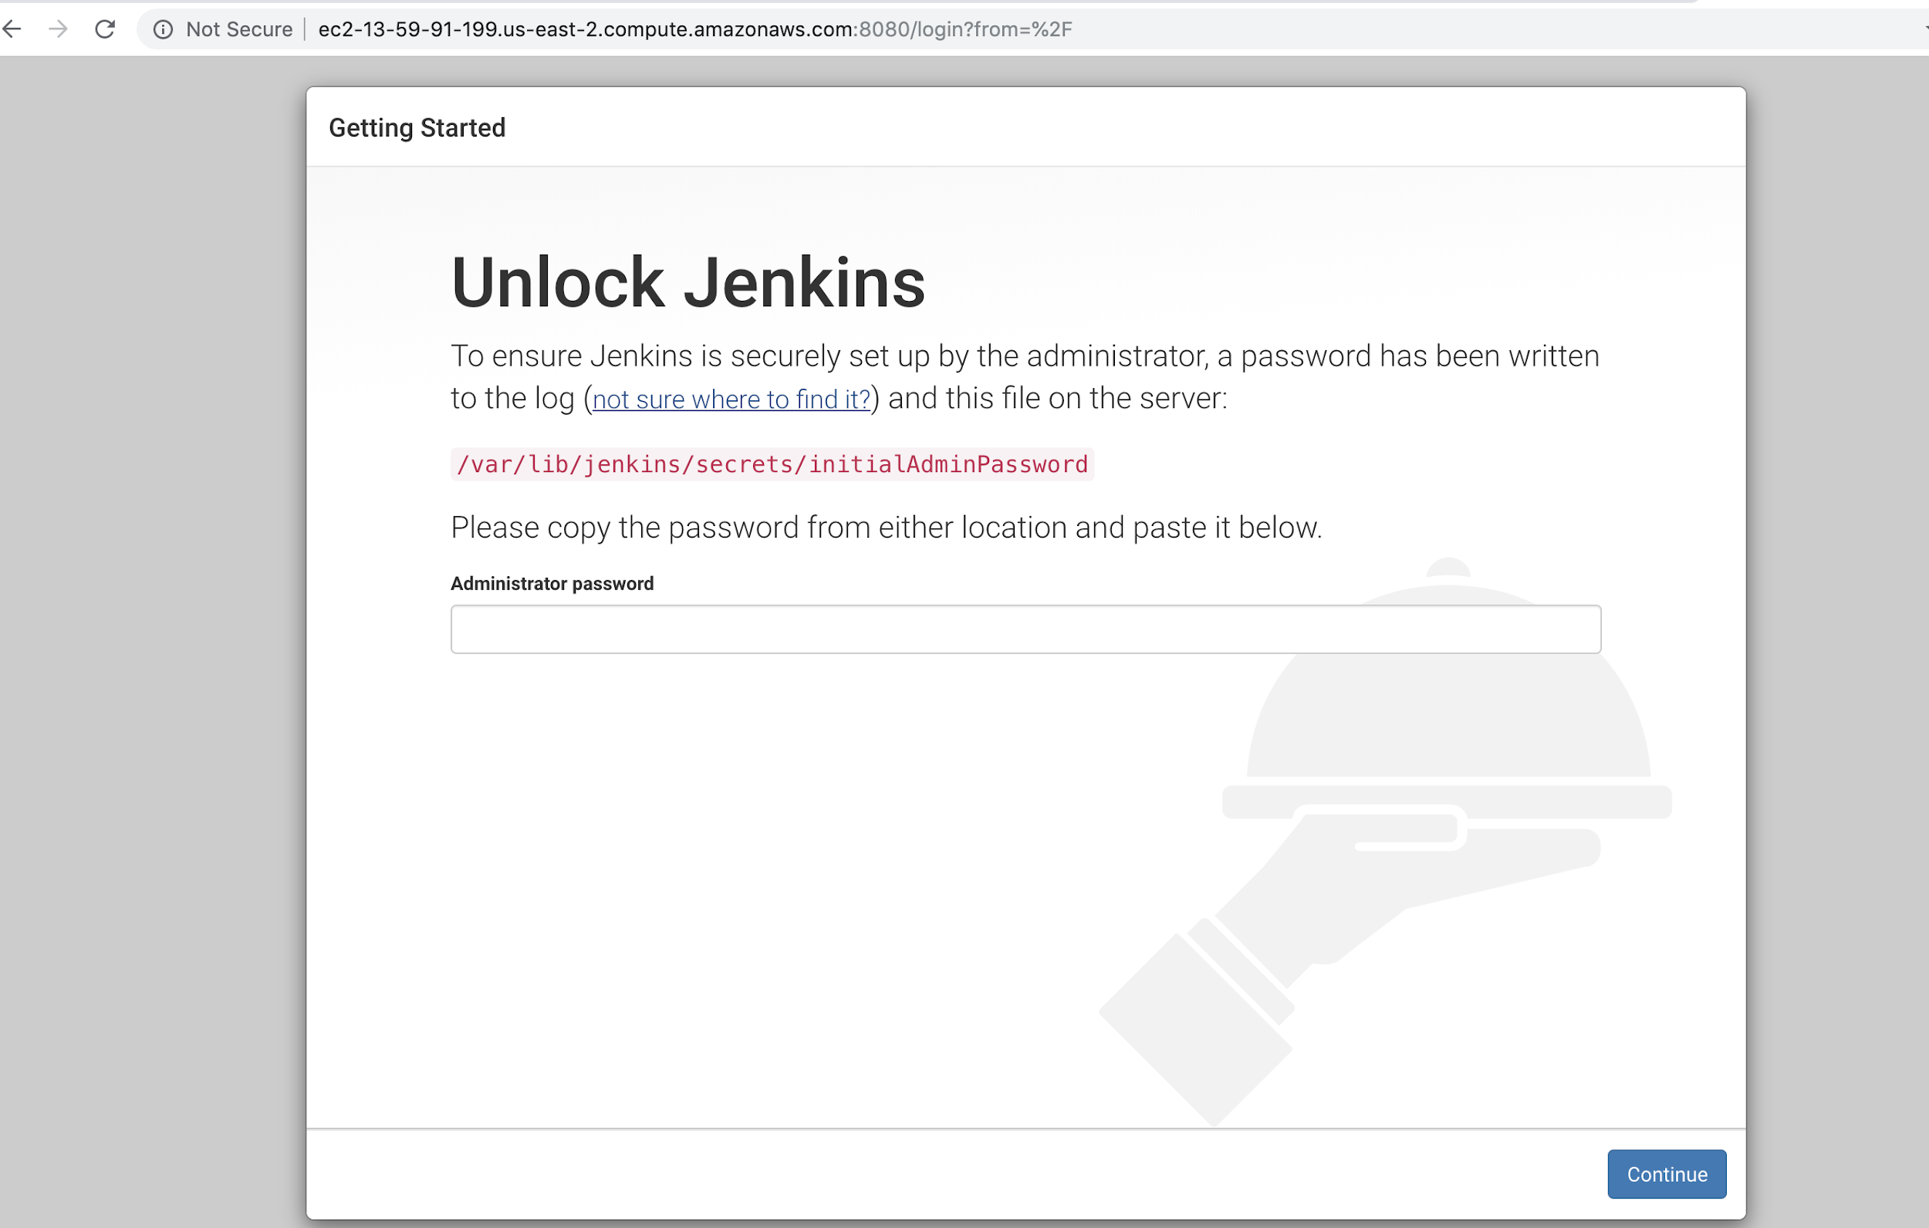

Select Install suggested plugins

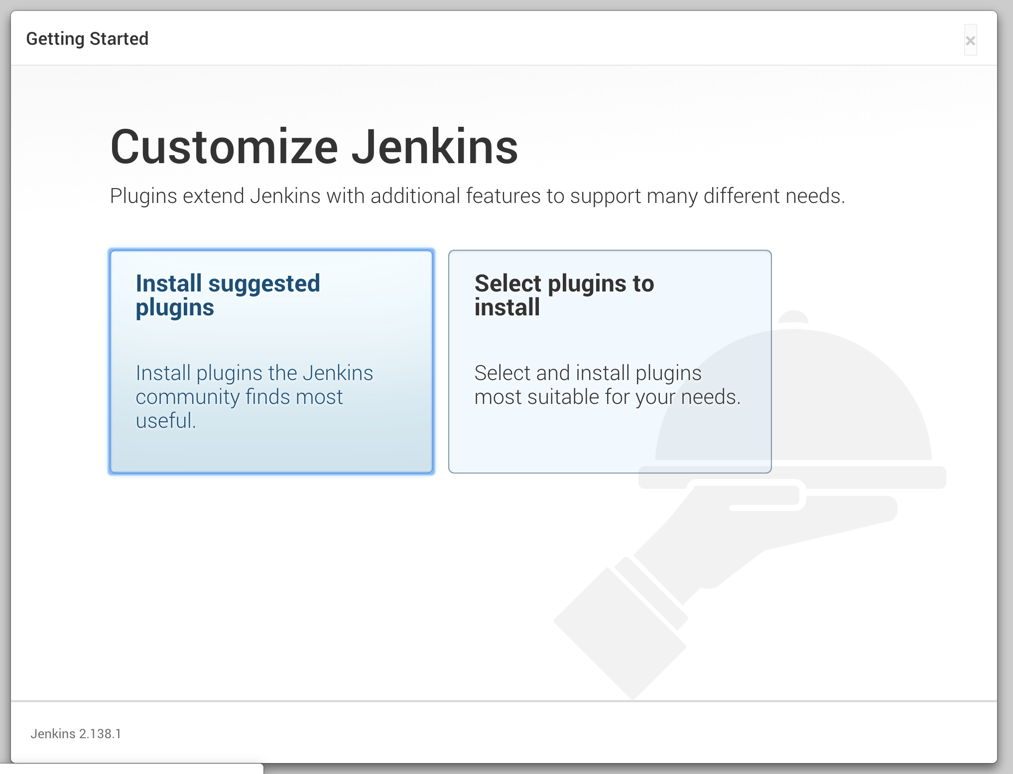

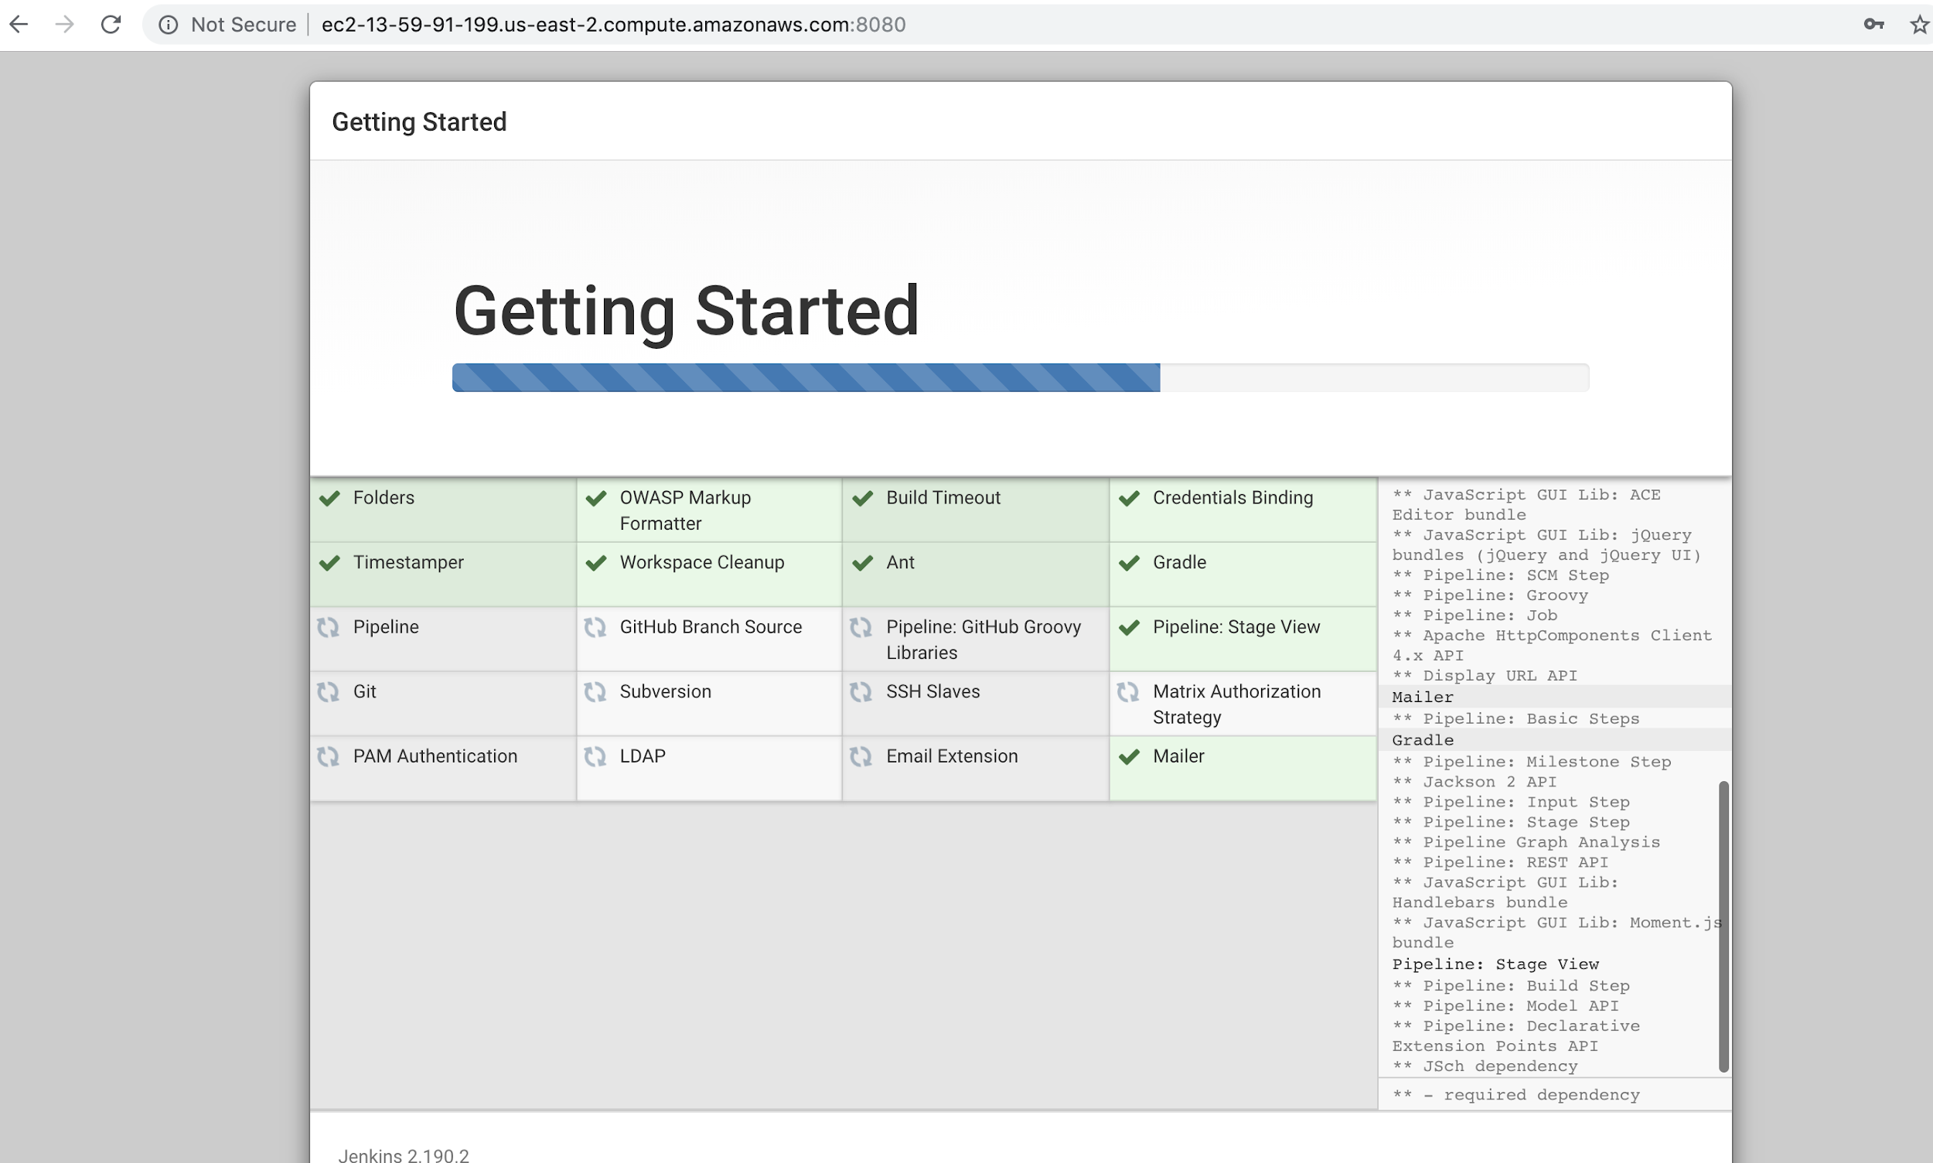

Create the jenkins admin user

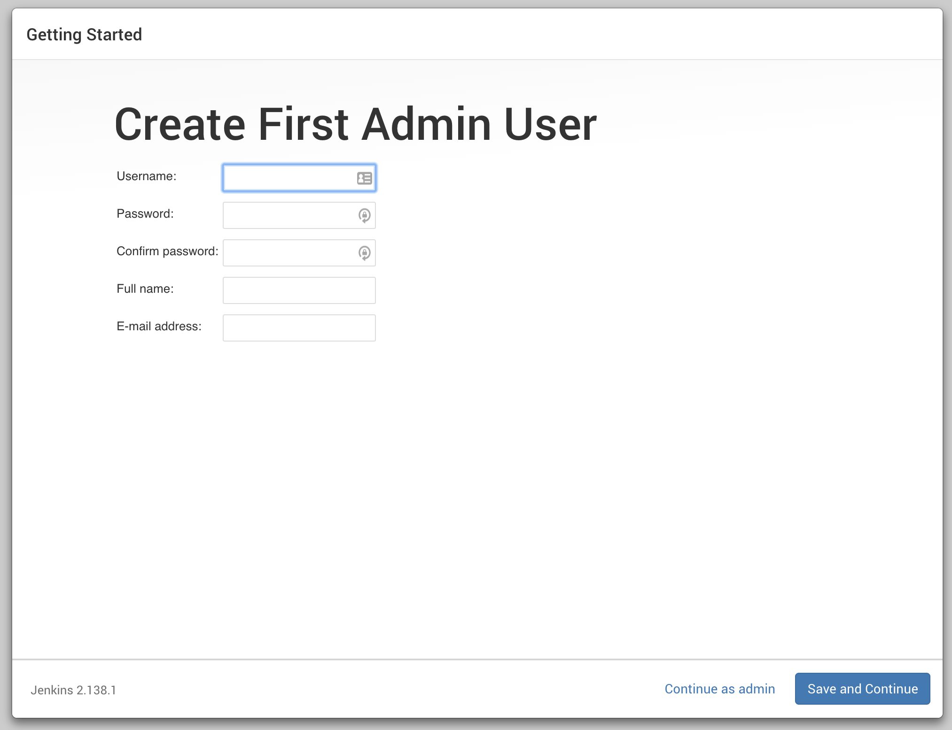

Instance Configuration

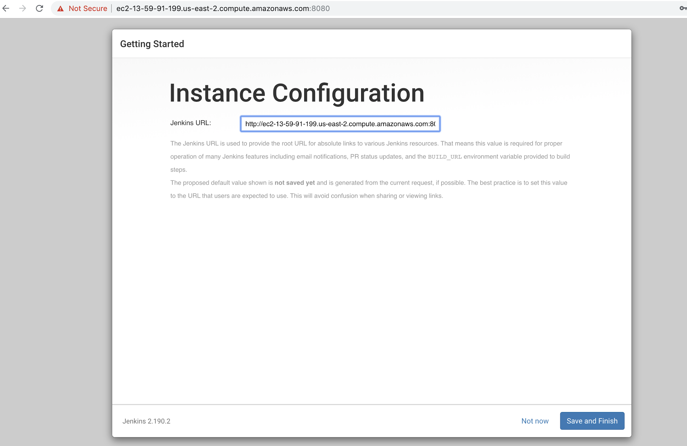

Select Save and Finish

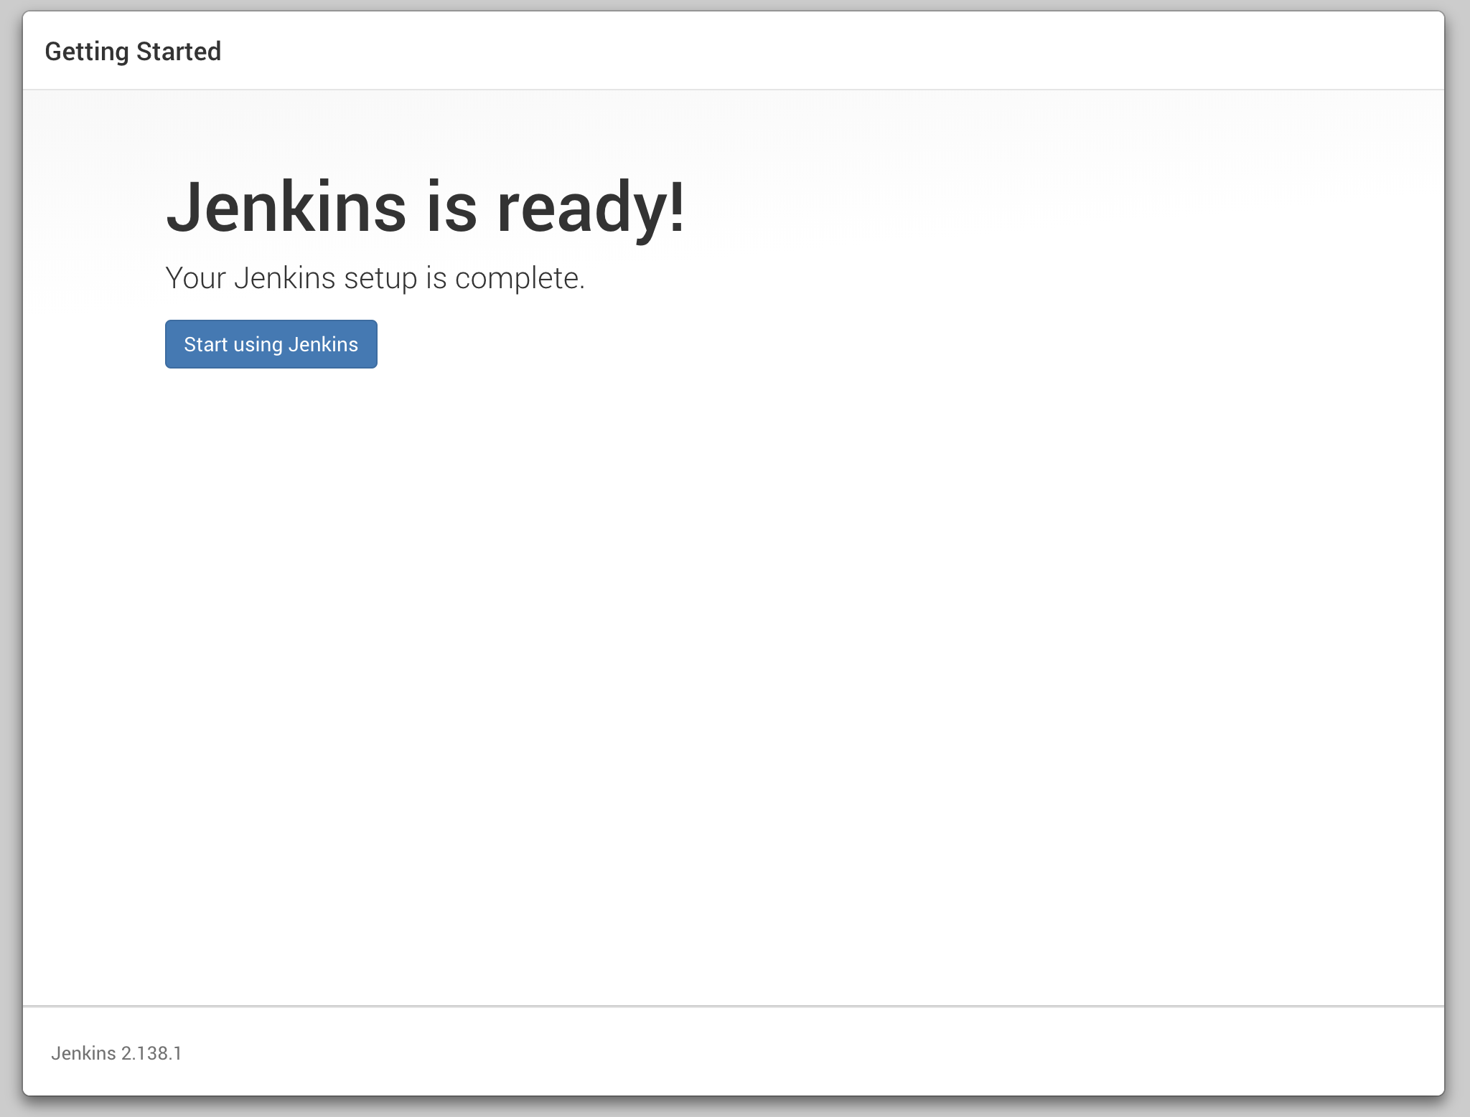

Add Jenkins User ssh key to GitHub settings to Provide Jenkins instance access to github repository

**cat ~/.ssh/id_rsa.pub**

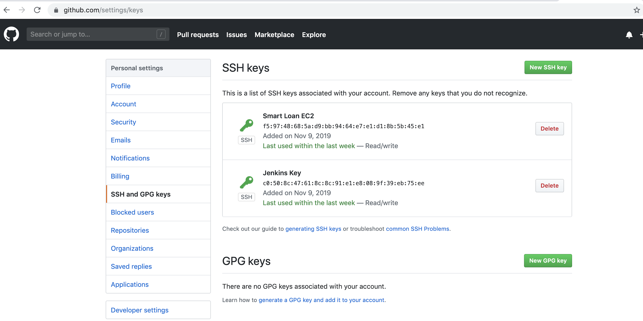

Configure Jenkins to integrate with GitHub

Install NodeJS plugin on the Jenkins Instance

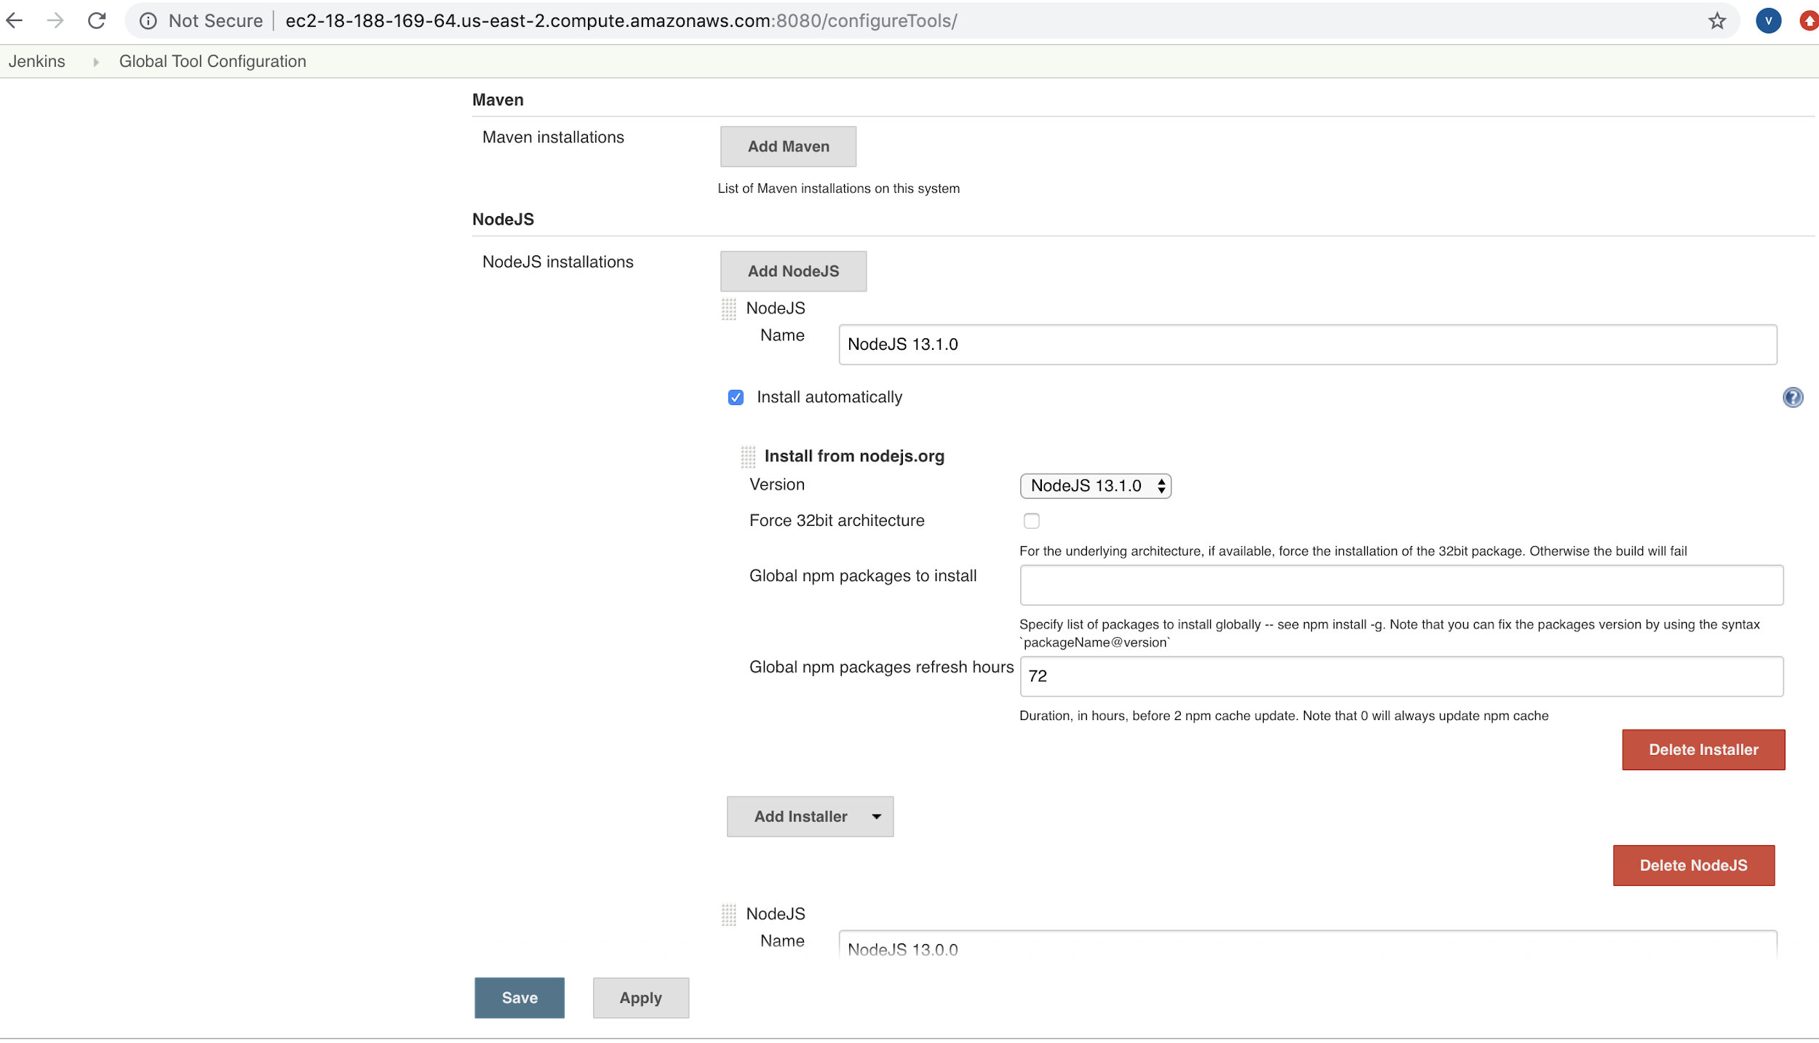

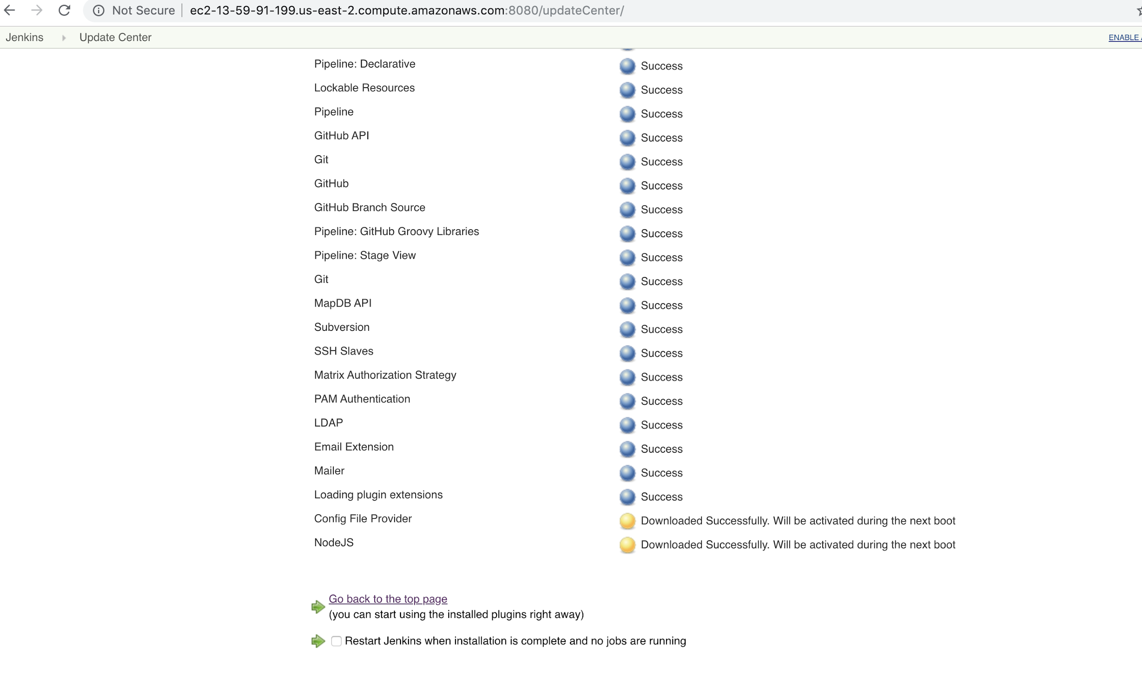

Restart Jenkins

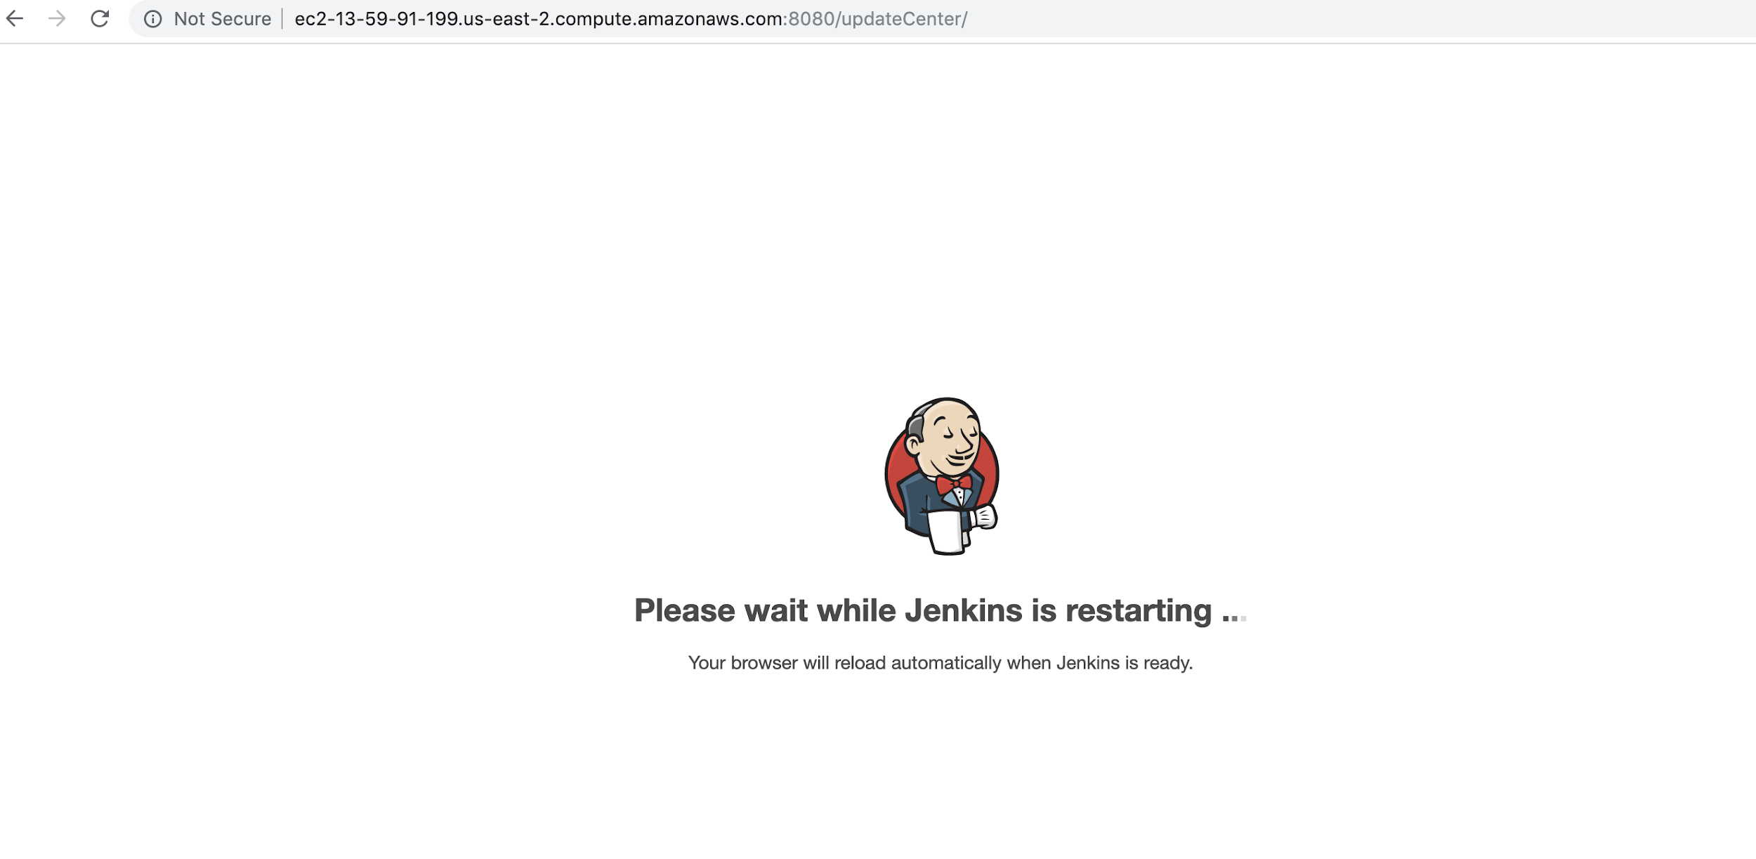

Create New Jenkins Job

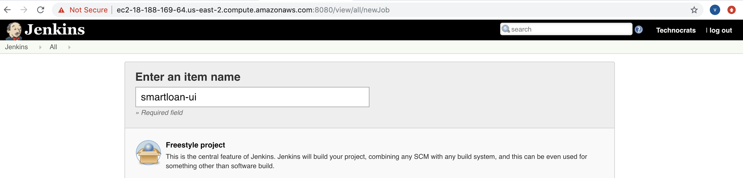

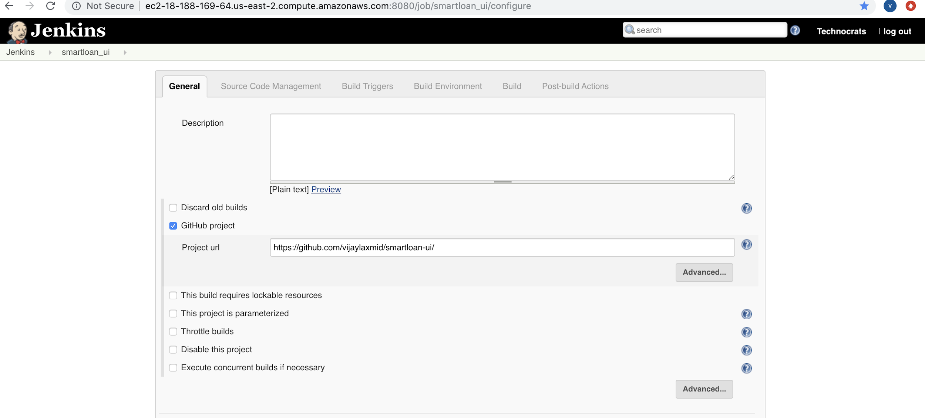

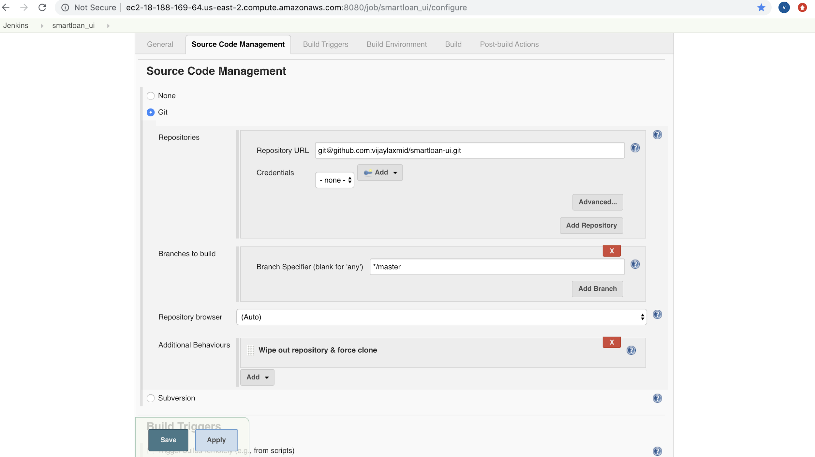

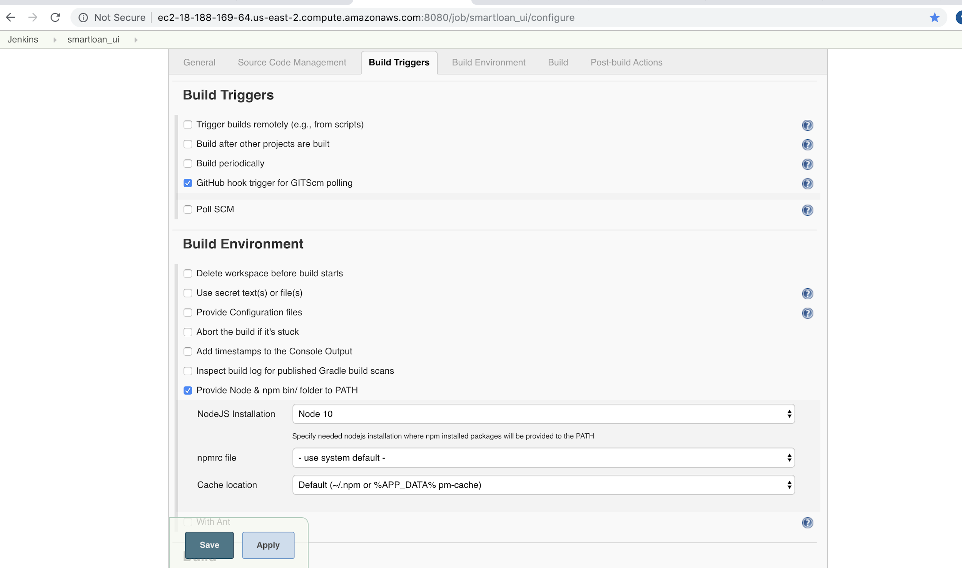

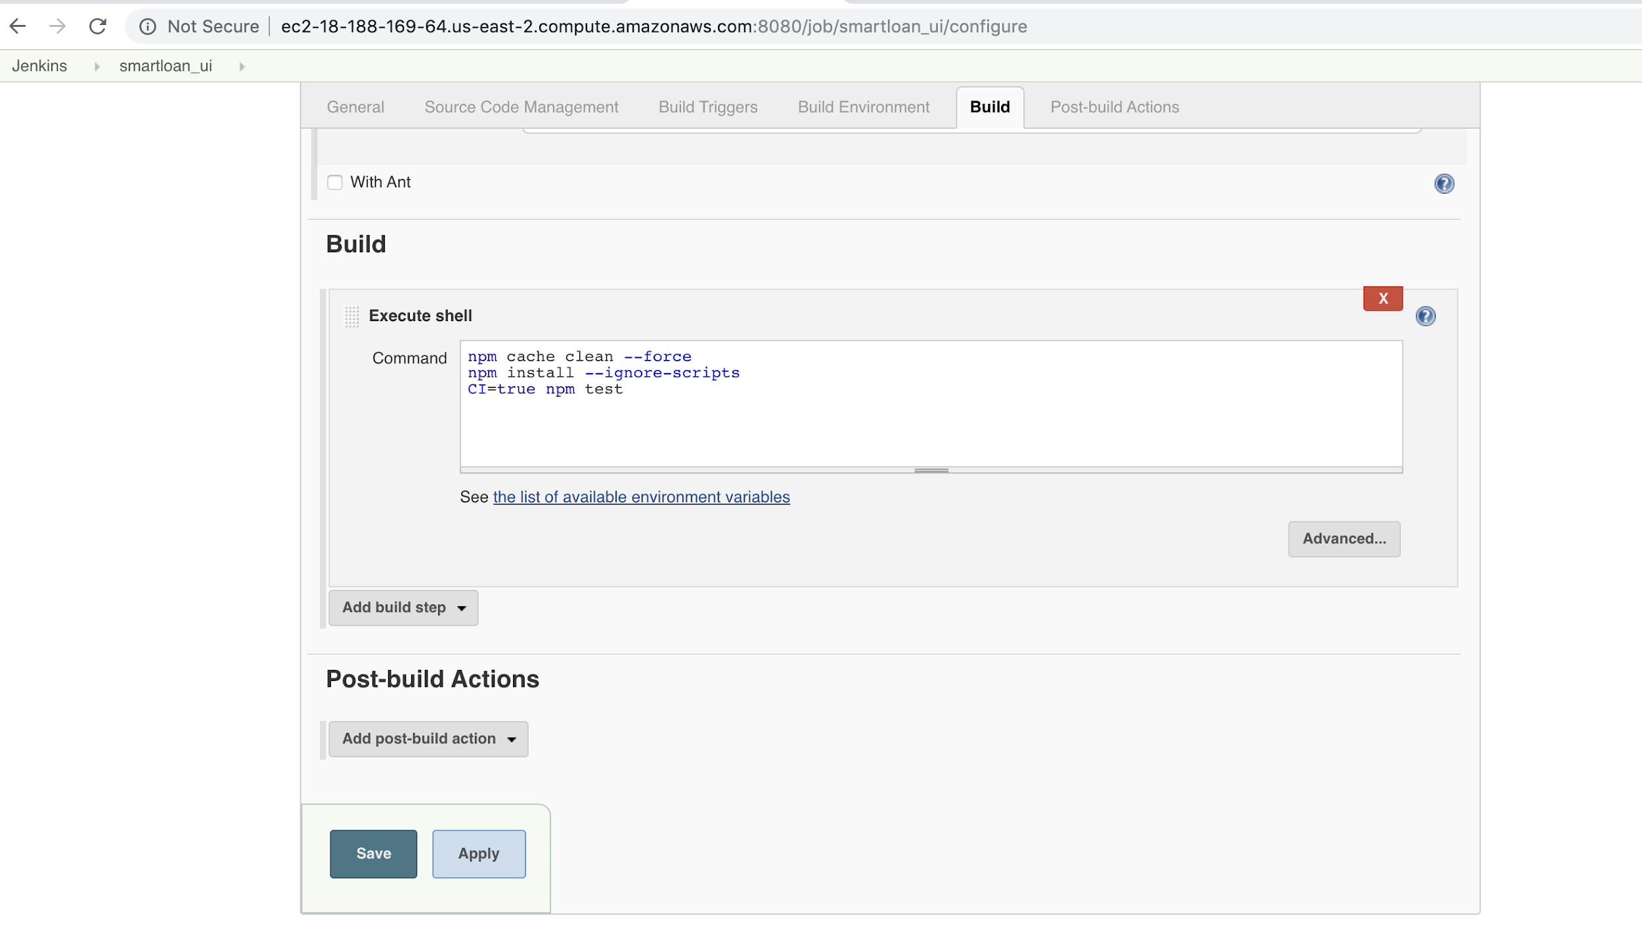

# Git WebHooks

Add Git Webhooks in Github Repository to the GitHub repo

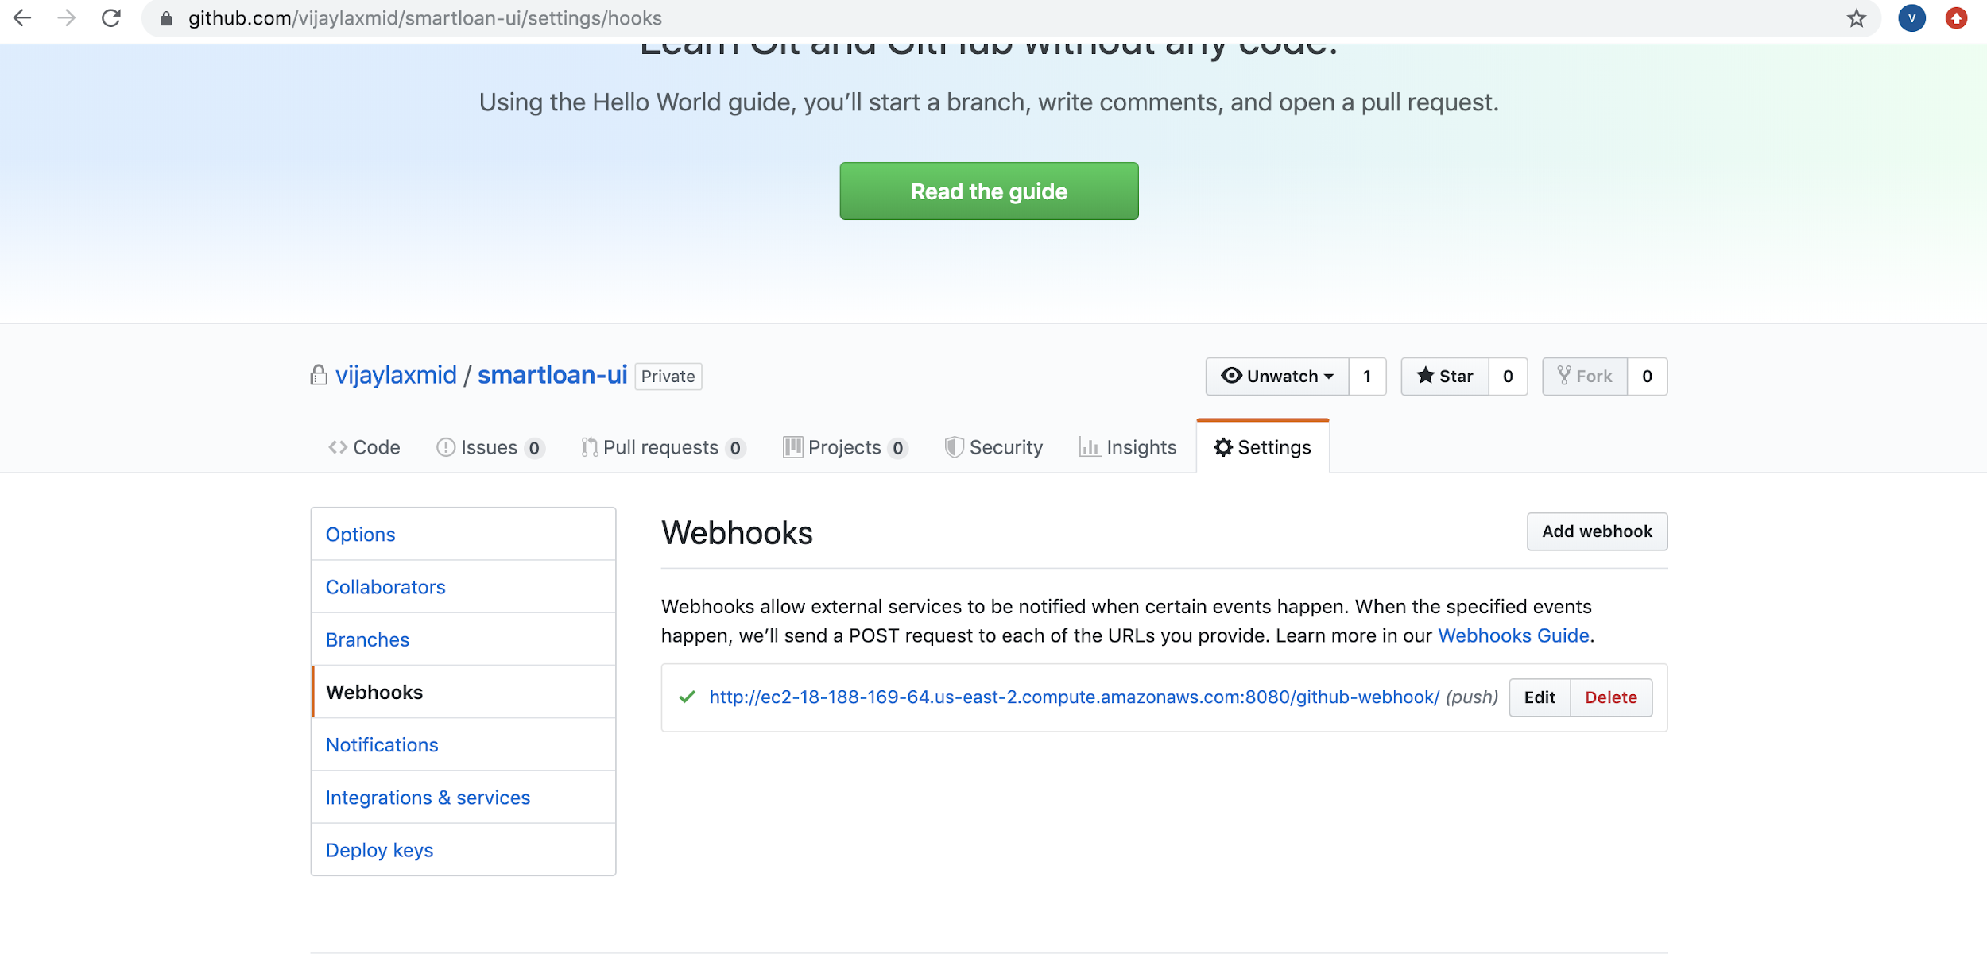

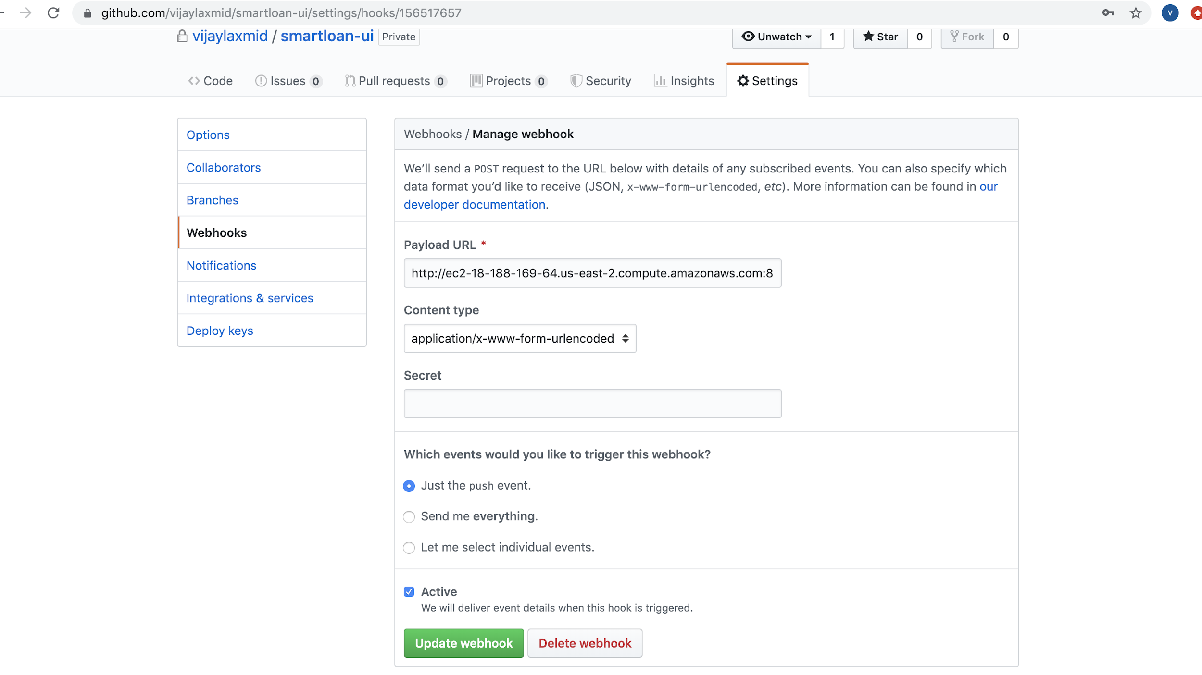

# GitHub Integration With Jenkins

Commit Code to master branch of the github repository and Push to Git

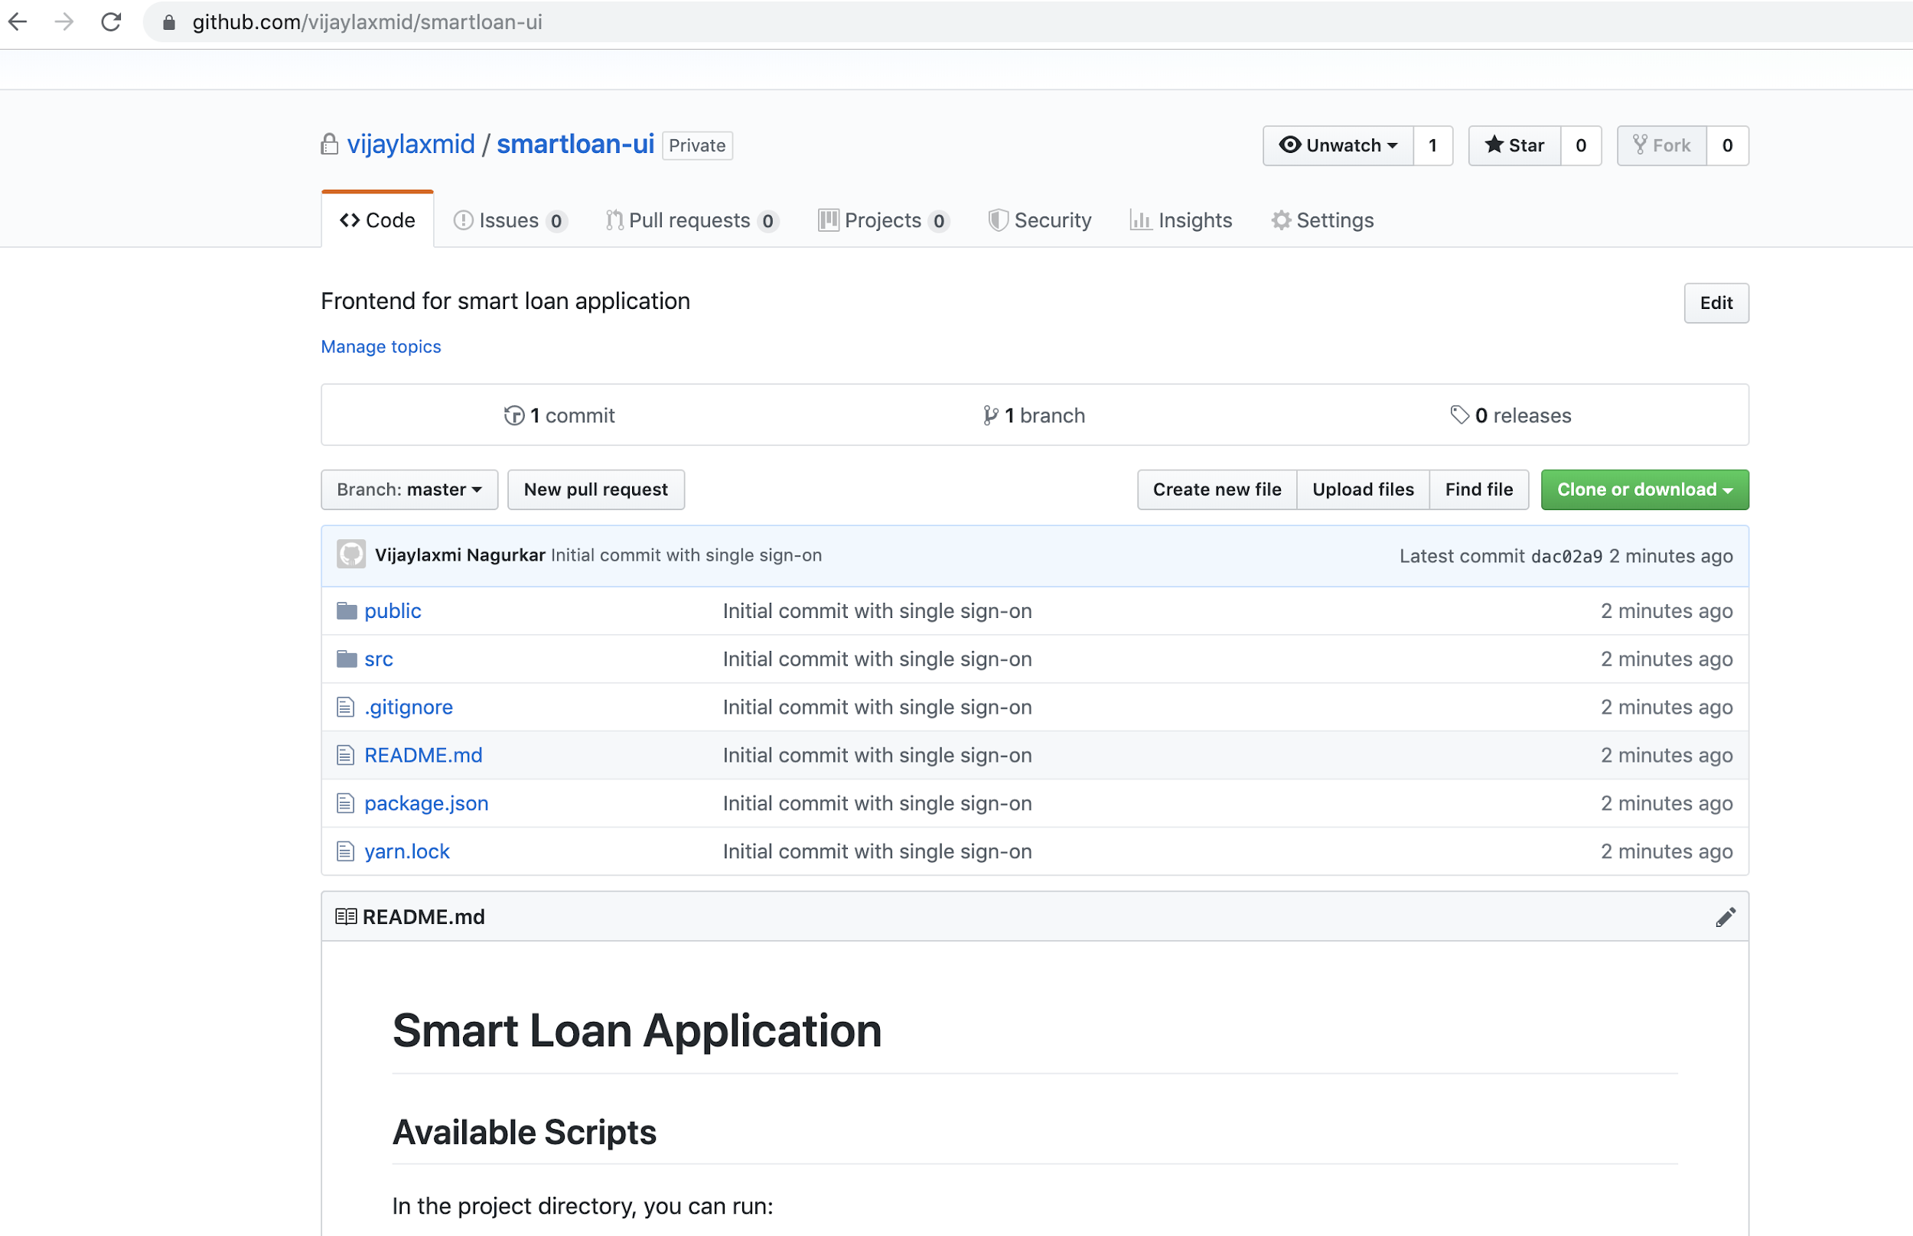

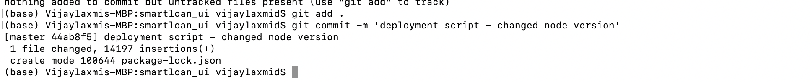

Webhook is activated and sends payload

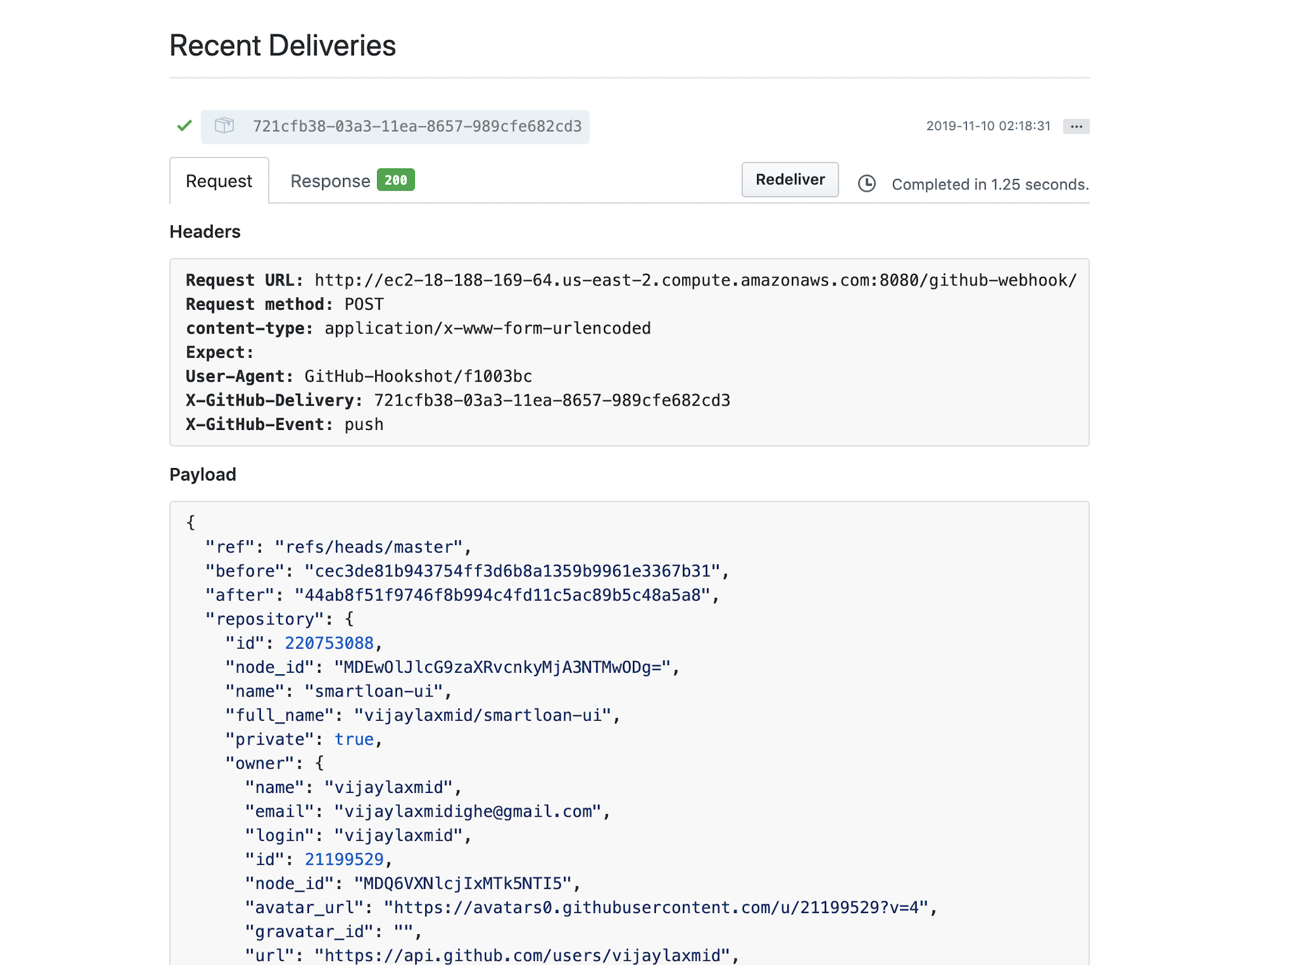

Check for the job on Jenkins

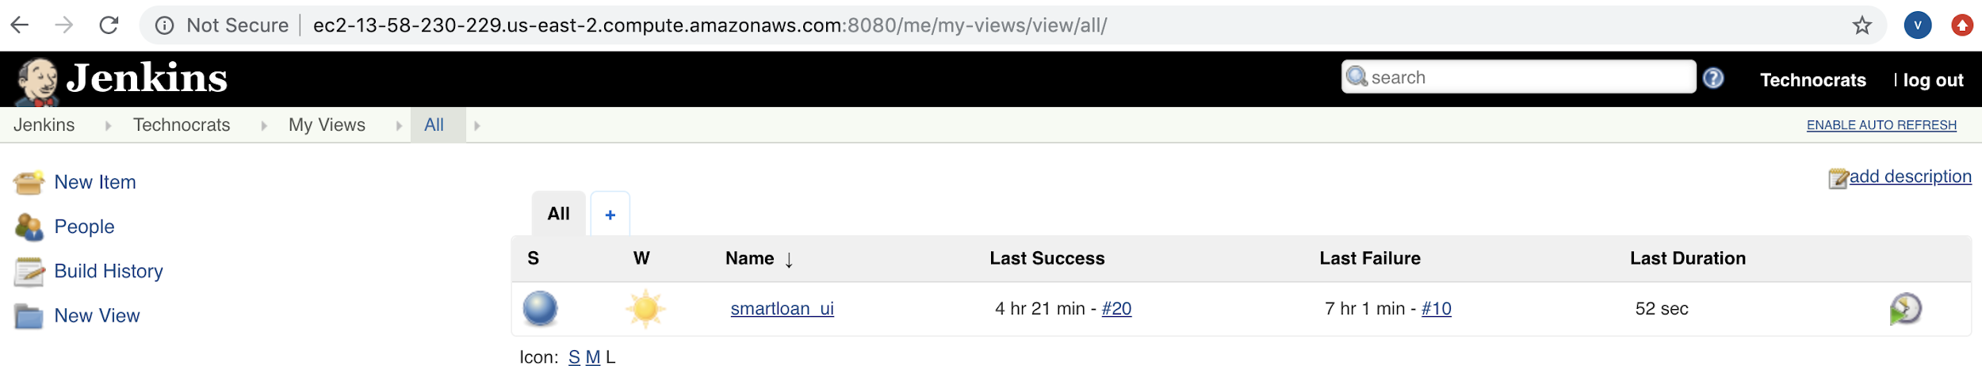

**Note : Commit to master should start the build and build should finish successfully. Please check that the same commit message is being shown while building the jenkins job**

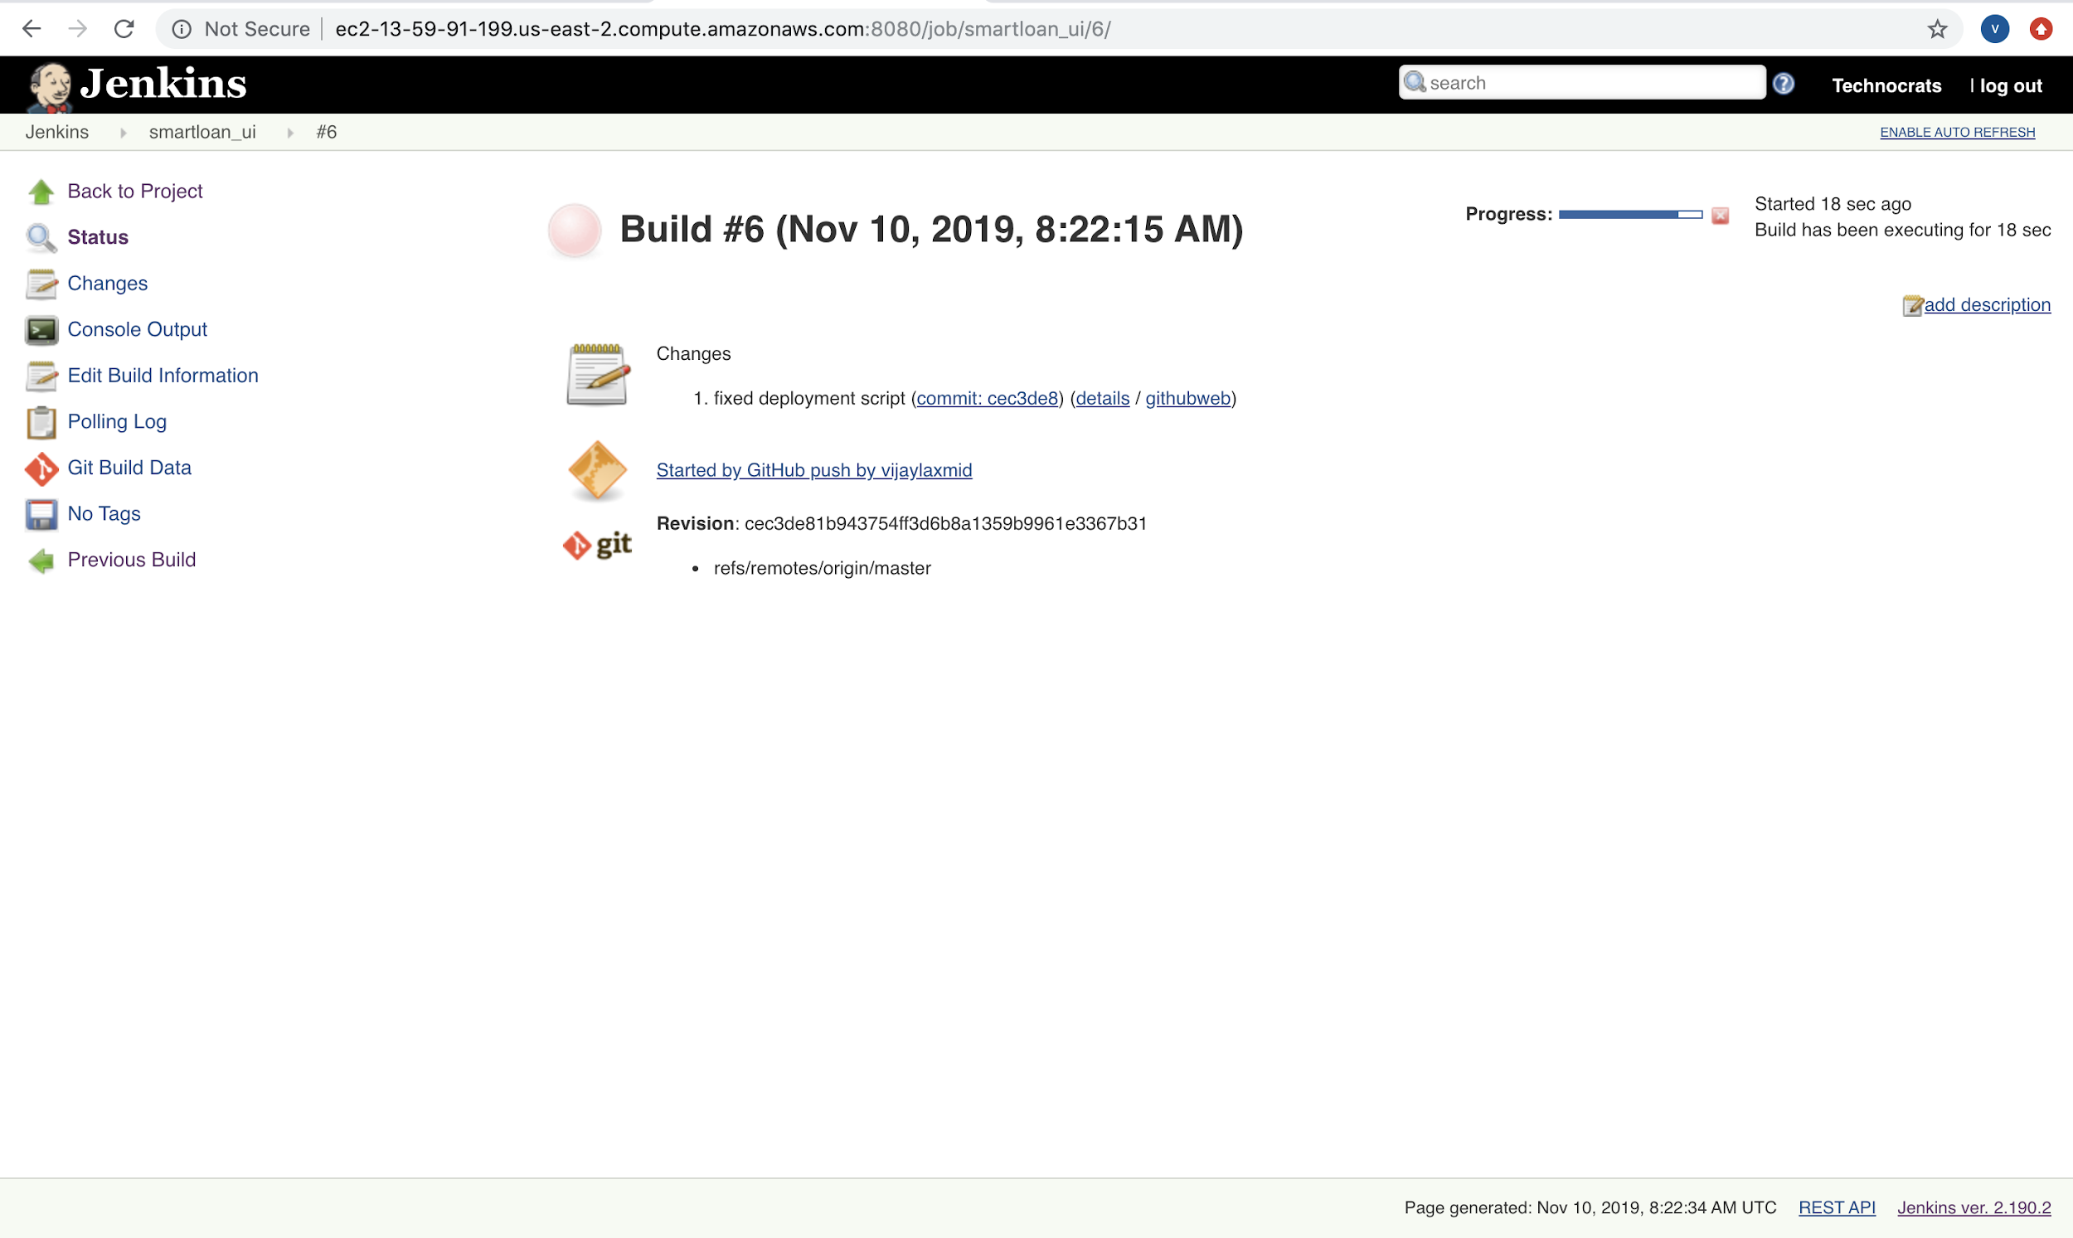

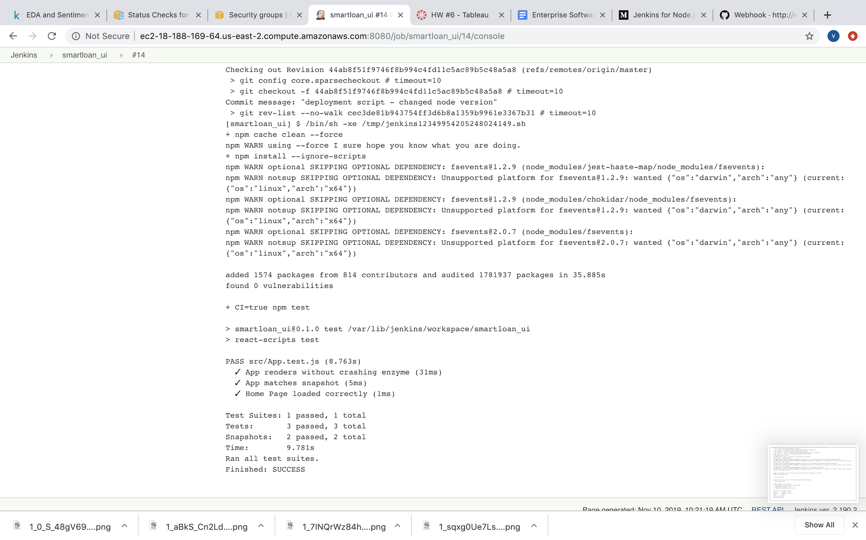

Pull requests merge to master should also trigger an automatic job

